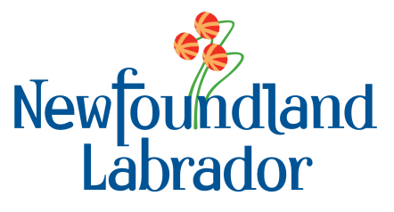

Stephen Lucas
Deputy Minister
Environment and Climate Change
Government of Canada
200 boul. Sacre-Coeur
2nd Floor, Office 249
Gatineau, QC K1A 0H3
stephen.lucas@canada.ca

Dear Mr. Lucas:

RE: Regulatory Design Paper

The Government of Newfoundland Labrador has reviewed Environment and Climate Change Canada’s December 20, 2018 Clean Fuel Standard Regulatory Design Paper. Please find attached the Department of Natural Resource’s comments.

We look forward to hearing from you. Thank you.

Sincerely,

Ted Lomond
Deputy Minister

